Experiment 5

UCD Diagram

Software engineering

Introduction

# A use case diagram is a dynamic or behavior diagram in UML. Use case diagrams model the functionality of a system using actors and use cases. Use cases are a set of actions, services, and functions that the system needs to perform. In this context, a "system" is something being developed or operated, such as a web site. The "actors" are people or entities operating under defined roles within the system.

# Basic Use Case Diagram Symbols and Notations

1. System

Draw your system's boundaries using a rectangle that contains use cases. Place actors outside the system's boundaries.

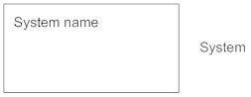

1. Use Case

Draw use cases using ovals. Label the ovals with verbs that represent the system's functions.

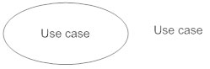

1. Actors

Actors are the users of a system. When one system is the actor of another system, label the actor system with the actor stereotype.

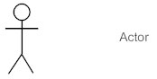

1. Relationships

Illustrate relationships between an actor and a use case with a simple line. For relationships among use cases, use arrows labeled either "uses" or "extends." A "uses" relationship indicates that one use case is needed by another in order to perform a task. An "extends" relationship indicates alternative options under a certain use case.

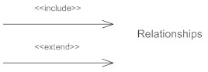

USE CASE DIAGRAM

----------------------------------------IMAGE HERE--------------------------------------